**Loves Creek Station**

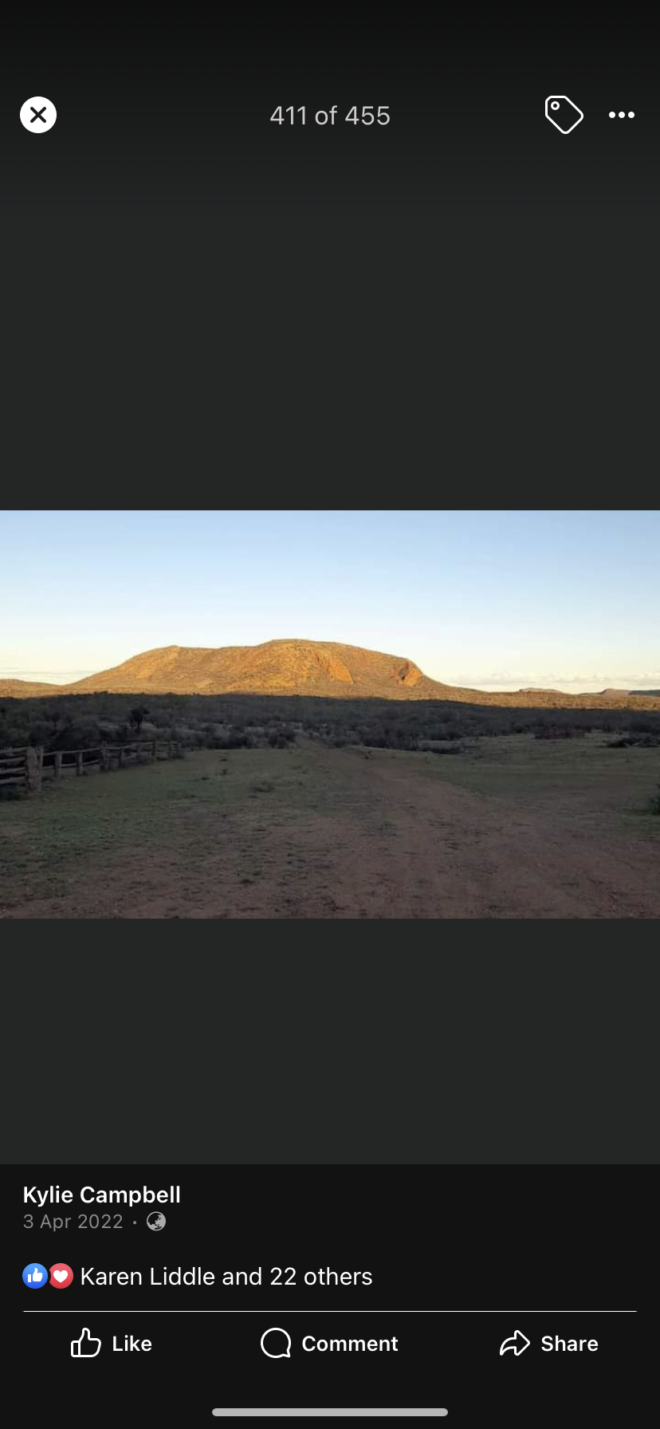

**Introduction**

Atnarpa Homestead also known as Loves Creek station was established 1896 and has been running cattle for more than 100 years. The homestead is situated east of Alice Springs on the Ross Highway a 1 ½ drive (4WD only)

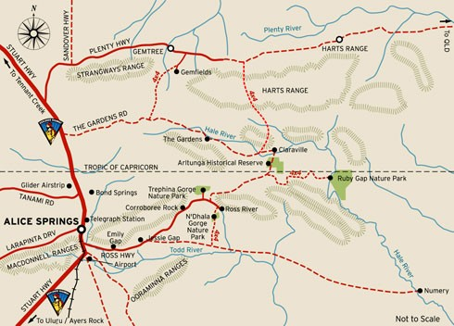

The history of Atnarpa (Loves Creek) is significant in that the building materials for the homestead was sourced from the surrounding local environment. The old homestead was built in 1933 with rocks from the local area and clay from the swamps around Loves Creek. The old stockyard is still standing and was built earlier than the homestead. Loves Creek Station was established primarily for the purpose of a cattle station. The practice continued for more than 100 years.

Atnarpa and Undoolya Station are the outstations of Loves Creek Station which is now named Ross River. The land claim for the Traditional Owners was lodged in 1994 and in July 2012 the Land Title was handed back to the Traditional Owners the Bloomfield/Wiltshire family. Who have formulated a plan to return as a family group to Atnarpa Outstation to share our cultural heritage and country with others.

The pioneering Bloomfield family ran cattle and bred horses for the Indian Remount trade (Army) during the British Empire World War II and the Aboriginal Bloomfield family maintained their connection to land in the Loves Creek area by practicing cultural ceremonies and rituals.

During the 1970’s the Traditional Landowners started lobbying for living spaces on the property and the CLC helped them purchase the Homestead using ABTA (Aboriginal Benefits Trust Account, now the ABA) funds in March 1993.

Atnarpa Homestead was built from clay mixed with large stones & spinifex grass as a binder, the walls are 2 feet thick. **Our aim** (is to restore the homestead to its original condition using local materials if available).

We the Bloomfield family would like to restore the old homestead as it is very special to our family with the history of Loves Creek Atnarpa.

**(Max Bloomfield)** **(Max and Son Henry Bloomfield)**

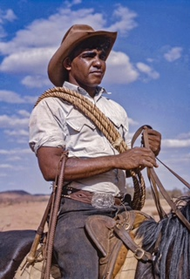 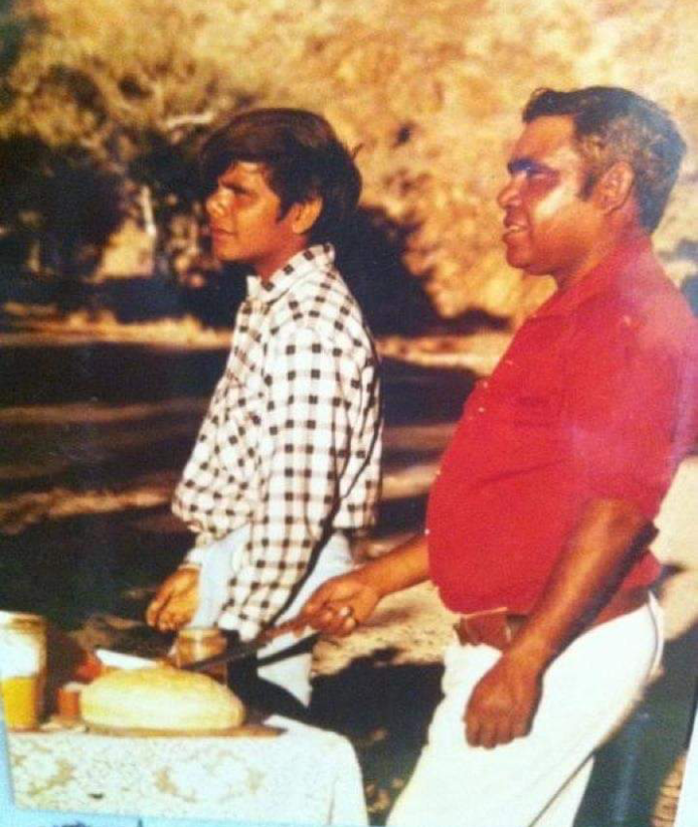

Atnarpa homestead is a very significant place to our family history. Our father Henry Bloomfield grew up as a kid at Atnarpa along with his Mother Edna Wiltshire and Father Max Bloomfield. Our grandparents Max and Edna lived at Atnarpa worked most of their lives at Atnarpa before moving to Ross River with Green Family.

Atnarpa is one of the outstations apart of Loves Creek station and is situated on the top end of the Loves Creek on the Ruby gap road.

The history of Atnarpa (Loves Creek) is quite amazing the old homestead was built in 1933 with rocks from the local area and the clay mix with the large stones & spinifex grass as a binder. The walls which are a metre thick allows the house in the summer to be nice and cool and in the winter to be warm with a huge fireplace in the middle of the house.

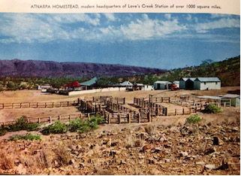

In 1994 our family was a part of the land claim that was lodged in 1994.

Being a part of the land claim was such a privilege and an experience like none other. We were able to listen to the stories that were told about the land and how significant they were to us all. The traditional songs and dances that were sung every night around the campfire showed us a great deal of respect for our land and where we come from.

**Native Title**

In July 2012, the land title was handed back to the Traditional Owners of Loves Creek. This day was a very remarkable day in history for all the families from Loves Creek. Unfortunately, a lot of our elders where not there to be able to witness this historic day. Our elders would have been very proud of us being able to get our land handed back to us.

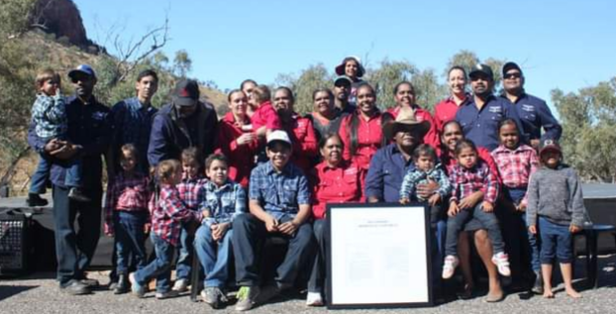**(Photo on bottom Henry Bloomfield and Family)**

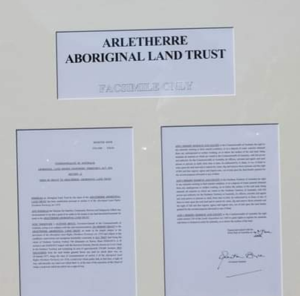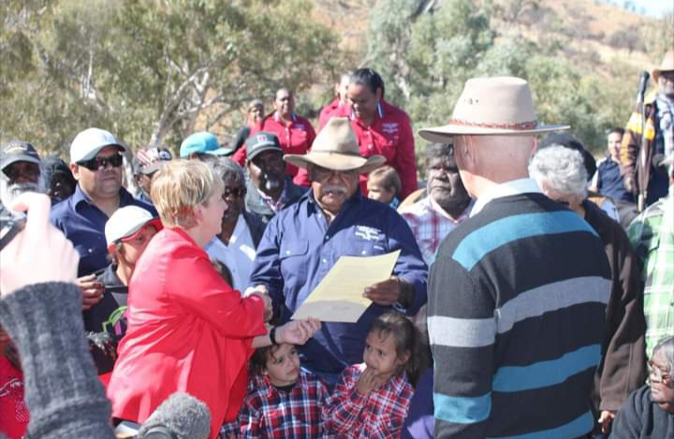

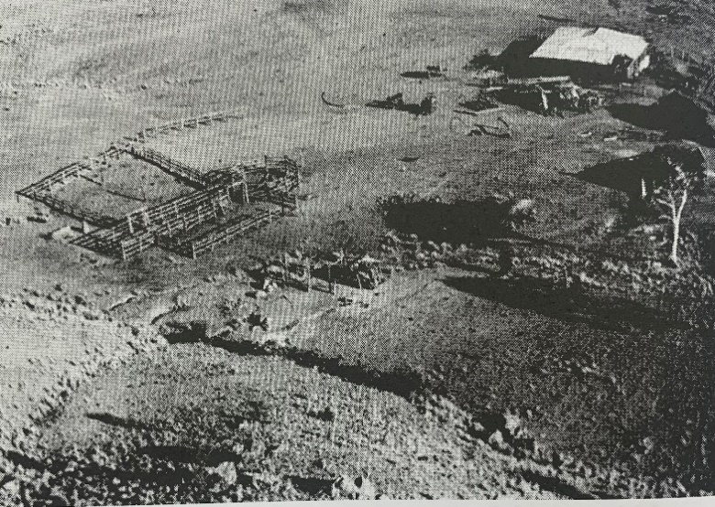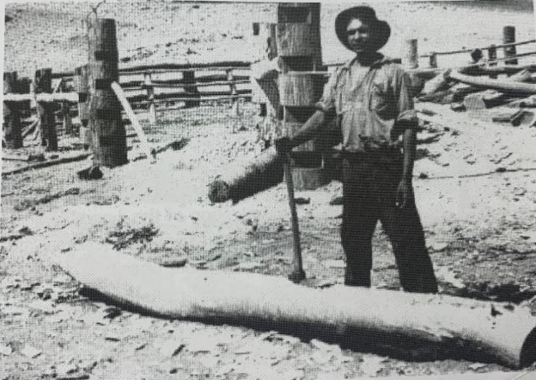The old stockyard was built years before the old homestead and was built with the river gum trees. The thickness of the yards allowed it to be strong and stable when holding cattle. Today the posts still stand strong with the upgrades of new logs.

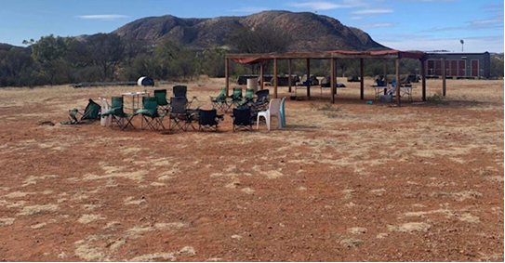**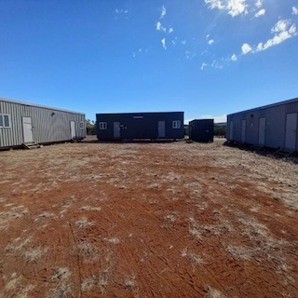Camping Facilities**

Atnarpa also has a campground area which has 3 accommodation blocks with beds, and a Self-contained kitchen, Shower and Toilet block. There is also more than enough room to find somewhere quiet for tents, campervans, and off-road caravans.

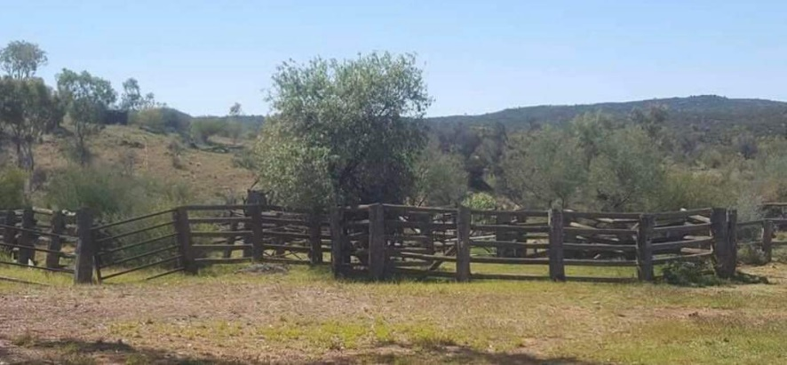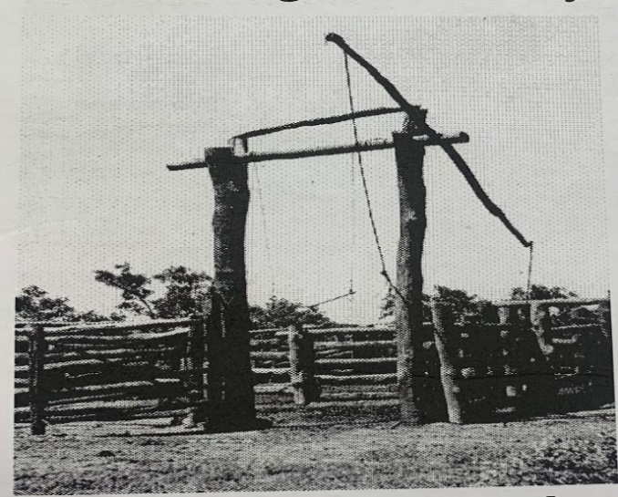

(Henry with his three daughters, niece, and grandchildren)

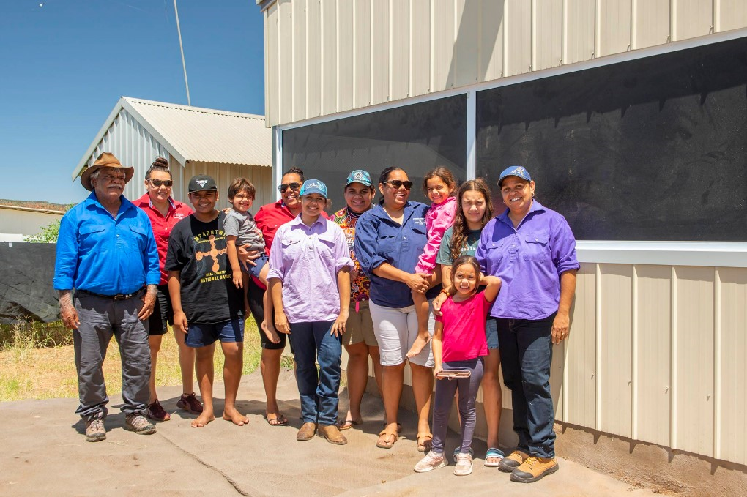

(Ross River school Henry and big Sister Rayleen Bloomfield with the Green Children)

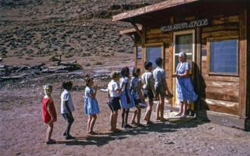

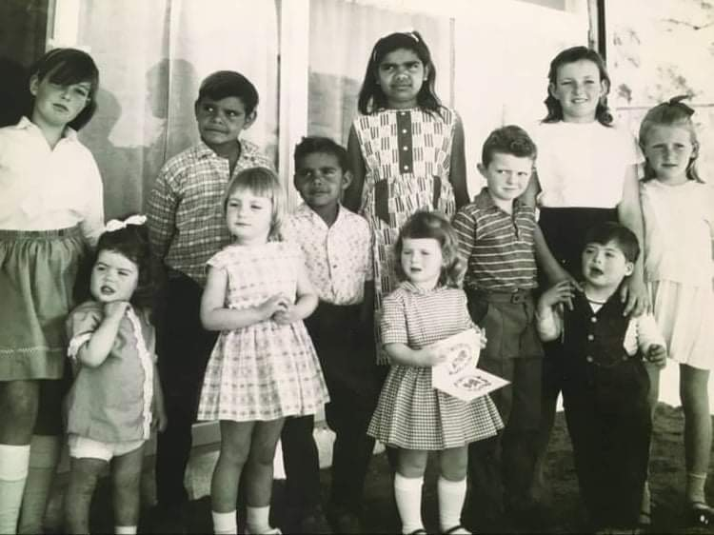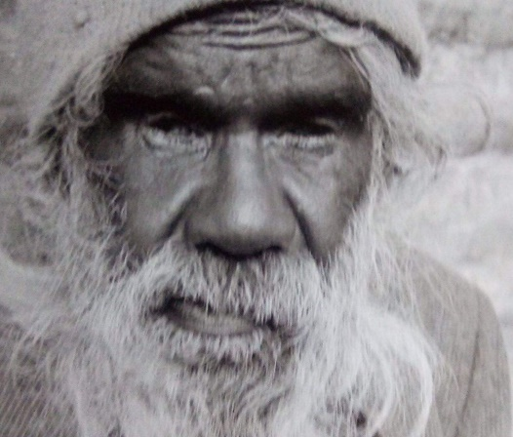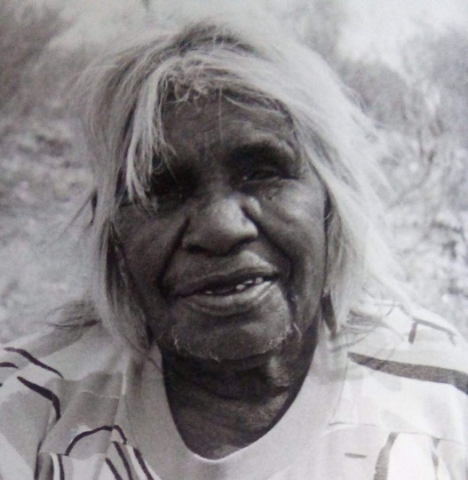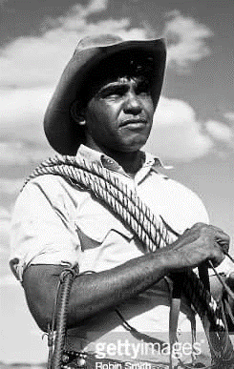

**Tourism**

Tourism has played a big part in our family history.

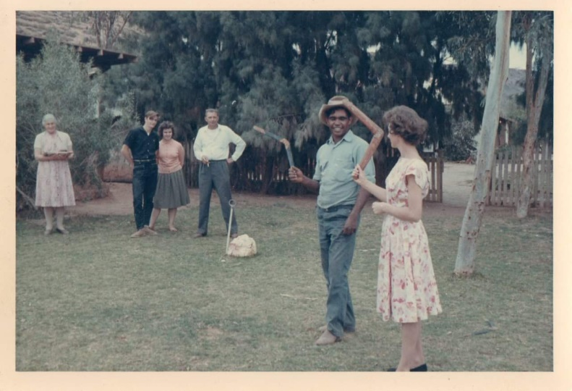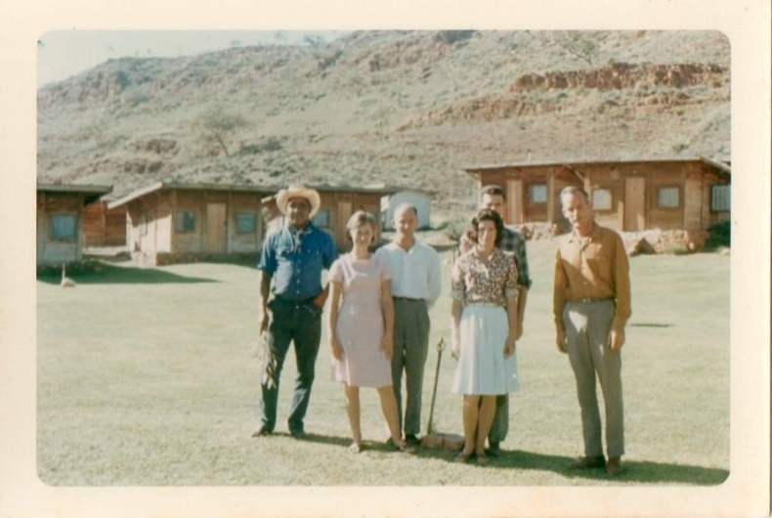Grandparents Max Bloomfield and Edna Wiltshire were Aboriginal tour guides at Ross River.

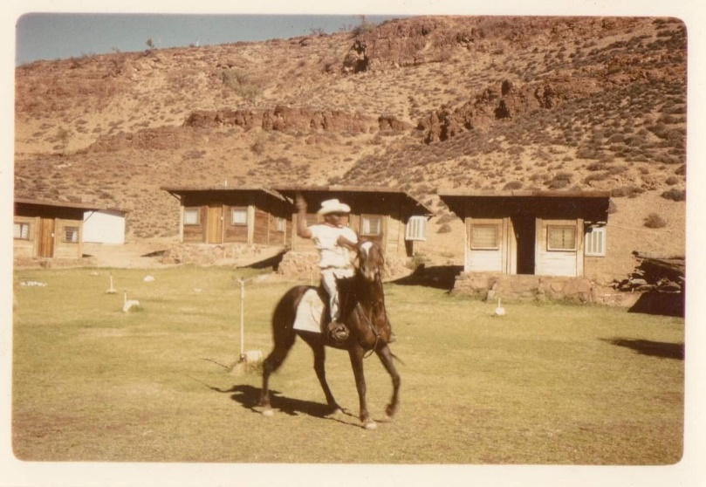

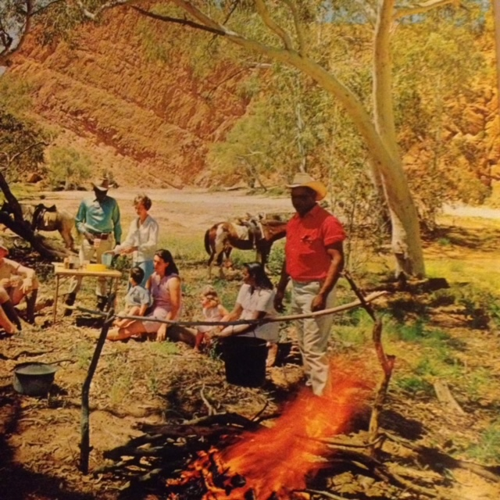

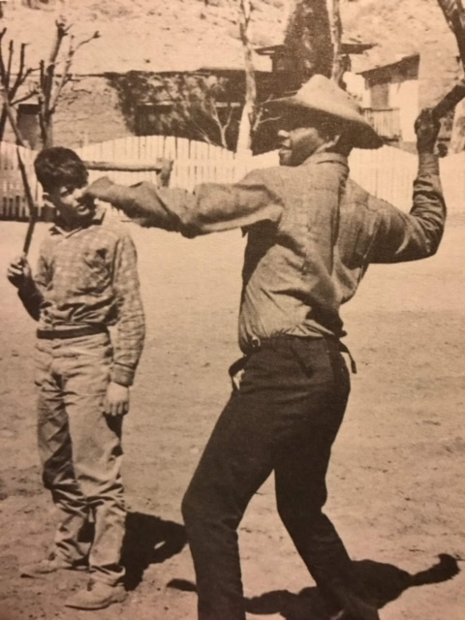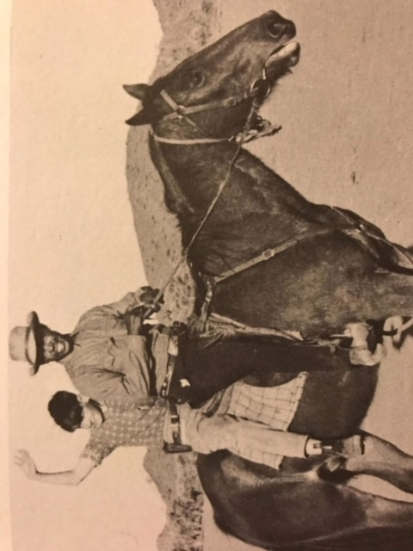

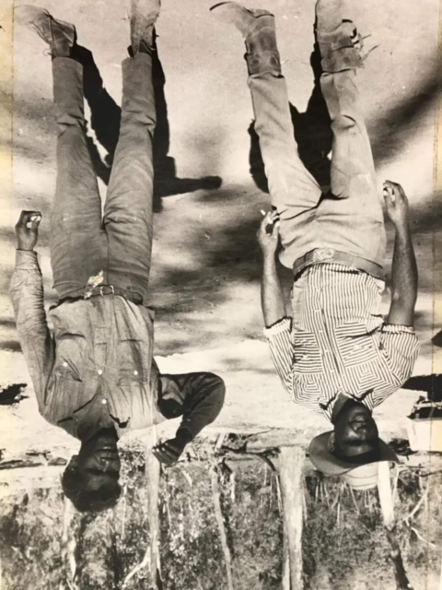

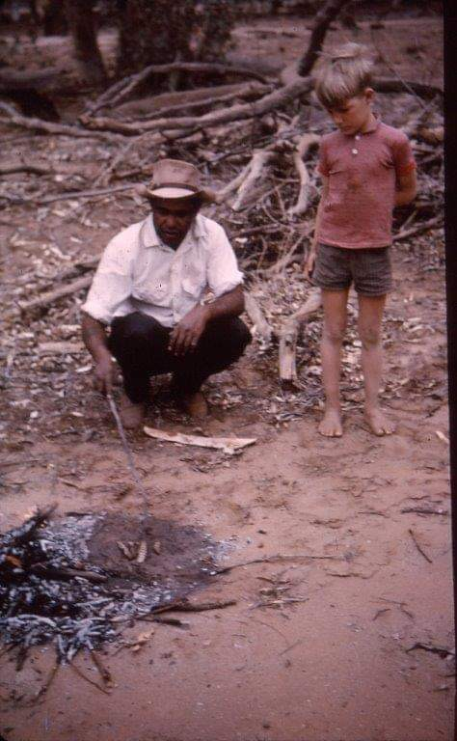

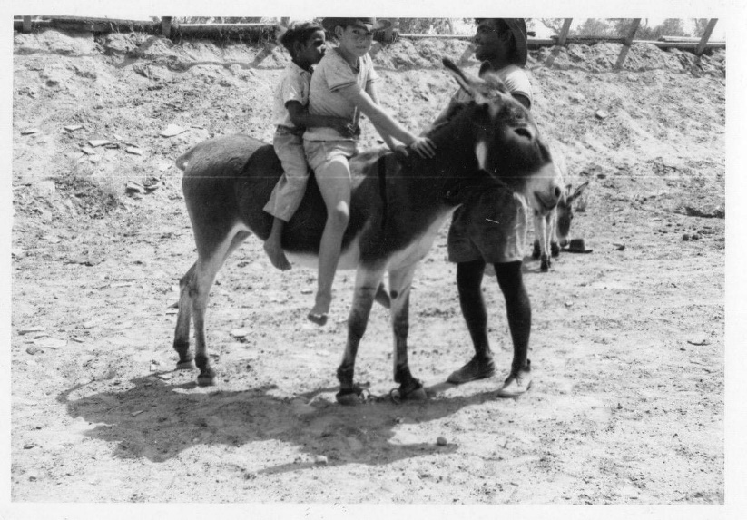

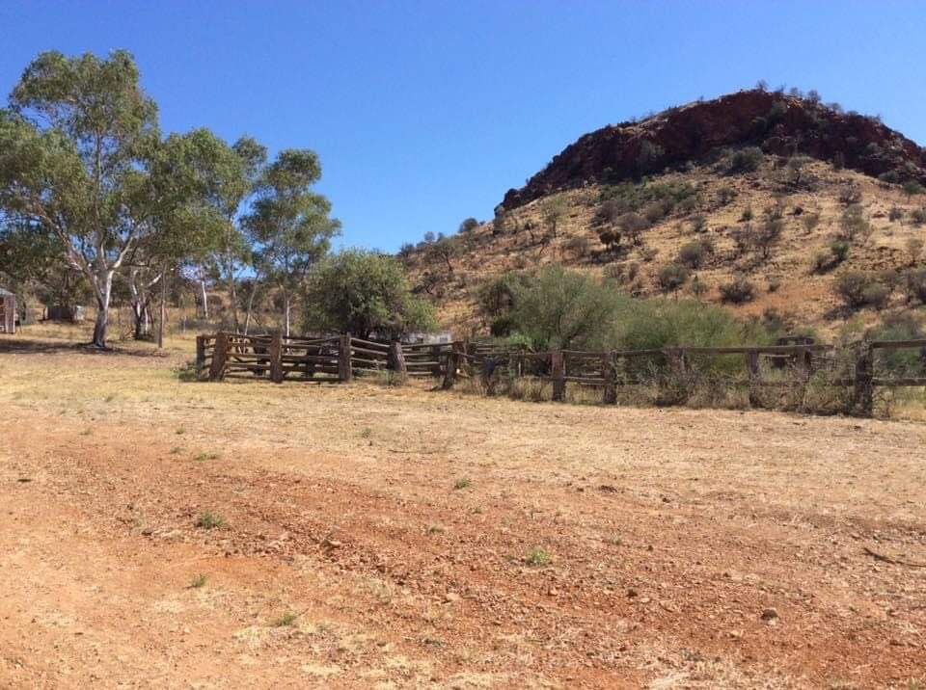**Atnarpa Homestead Lookout**

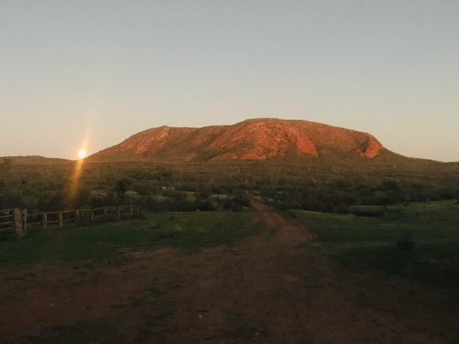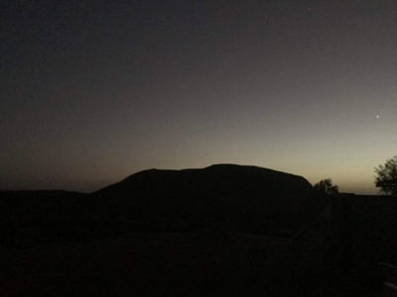

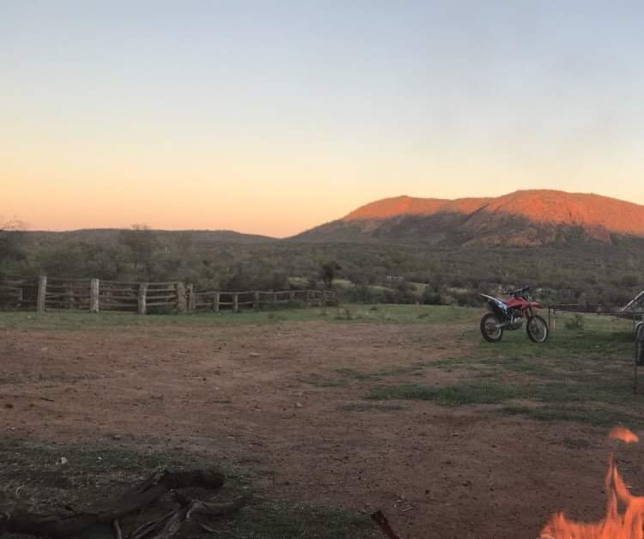

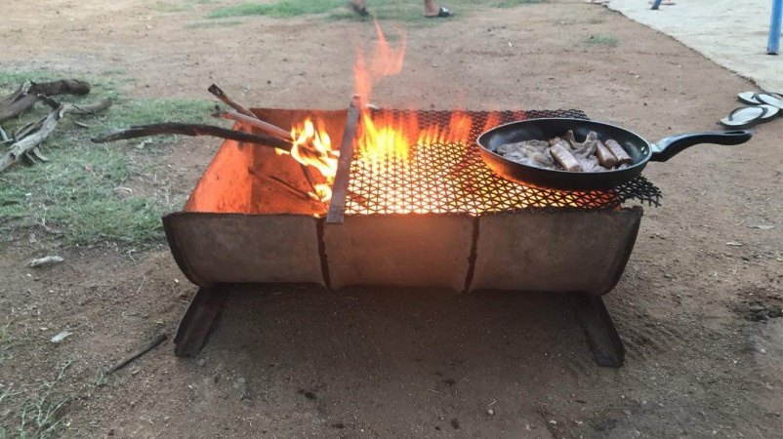

**Atnarpa Spring**

